11 Dec 2023

Customization Instructions v.1.1

1. Bulk Upload – As much as possible the native attributes of Bagisto 2.0 must be used.
   1. A subset of the original list of fields (attributes) are to be included in the upload:
      1. SKU
      2. Name
      3. URL Key
      4. Tax Category
      5. New
      6. Featured
      7. Visible Individually
      8. Status
      9. Short Description
      10. Description
      11. Price
      12. Special Price
      13. Special Price From
      14. Special Price To
      15. Meta Title
      16. Meta Description
      17. Brand
      18. Guest Checkout
      19. Product Number
      20. Manage Stock
   2. The excluded fields can be made invisible except for the weight attribute. It cannot be zero, please make the default value to be 537.
   3. Additional attributes are to be introduced:

|  |  |  |  |  |  |  |  |
| --- | --- | --- | --- | --- | --- | --- | --- |
| code | name | type | required | options | for config | comparable | visible |
| processing_fee | Processing Fee | price | true |  |  |  | true |
| location | Location | select |  | Laguna  Cavite  Rizal  Bulacan | true |  | true |
| floor_area | Floor Area (sqm) | text |  |  |  | true | true |
| lot_area | Lot Area (sqm) | text |  |  |  | true | true |
| finished | Finished | select |  | Bare,  Fitted | true | true | false |
| ground_floor | Ground Floor | select |  | Yes,  No | true |  | false |
| penthouse | Penthouse | select |  | Yes,  No | true |  | false |
| bedrooms | Bedrooms | select |  | Studio,  1-Bedroom,  2-Bedroom,  3-Bedroom | true | true | false |
| t_and_b | Toilet & Bath | text |  |  |  | true | true |
| carports | Carports | text |  |  |  | true | true |
| parking | Parking for Sale | boolean |  |  |  | true | true |
| end_unit | End Unit | Select |  | Yes,  No | true | true |  |
| veranda | Veranda | select |  | Present,  Absent | true |  | false |
| lanai | Lanai | select |  | Present,  Absent | true |  | false |
| balcony | Balcony | select |  | Present,  Absent | true |  | false |
| pd_options | Percent Downpayment Options | checkbox |  | Zero,  5,  10,  15,  20 |  |  | true |
| mtpd_options | Months to Pay Downpayment Options | checkbox |  | Spot,  6,  12  18,  24 |  |  | true |
| bp_options | Balance Payment Options | checkbox |  | cash,  bank loan,  Pag-IBIG loan,  in-house loan |  |  | true |
| amenities | Amenities | checkbox |  | clubhouse,  chapel,  basketball court,  playground,  jogging path,  dog path,  swimming pool,  gazebo,  24-hour security,  cctv,  emergency power |  |  | true |
| brochure | Brochure | file |  |  |  |  | true |
| kml_url | KML URL | text |  |  |  |  | false |
| ekyc_url | eKYC URL | text |  |  |  |  | false |
| property_map_url | Property Map URL | text |  |  |  |  | false |
| choose_property | Choose Property | boolean |  |  |  |  | false |
| purchase_requirements | Purchase Requirements | text |  |  |  |  | true |

1. ADD 2 categories apart from the “Root” category i.e., “House & Lot” and “Condominium”
2. ADD 2 attribute families apart from the “default” attribute family e.g., “House & Lot” (`house_and_lot`) and “Condominium” (`condominium`)
3. ALLOW CDN links to images/videos instead of uploading actual files
   1. instead of a local file i.e., “storage/theme/1/8dml8bq6ALdYMov6g86AttBPZGgWk7LZ0BXsmmNG.webp”
   2. use CDN i.e., “https://jn-img.enclaves.ph/Zaya/Keyplan/D02/Zaya_Keyplan_D-02_Second%20and%20Fourth%20Floor.jpg”
4. PROCESS formatted upload files:
   1. MS Excel with multiple worksheets i.e., Product SKUs, Inventory and Digital Assets (click link): <https://jn-storage.sgp1.cdn.digitaloceanspaces.com/devops/storefront/templates/Sta.%20Rosa%20Zaya%20Condominium%20Upload.xlsx>
   2. JSON
      1. Product SKUs (click link): <https://jn-storage.sgp1.cdn.digitaloceanspaces.com/devops/storefront/templates/Sta.%20Rosa%20Zaya%20Condominium%20Upload%20-%20Product%20SKUs.json>
      2. Inventory (click link): <https://jn-storage.sgp1.cdn.digitaloceanspaces.com/devops/storefront/templates/Sta.%20Rosa%20Zaya%20Condominium%20Upload%20-%20Inventory.json>
      3. Digital Assets (click link): <https://jn-storage.sgp1.cdn.digitaloceanspaces.com/devops/storefront/templates/Sta.%20Rosa%20Zaya%20Condominium%20Upload%20-%20Digital%20Assets.json>
5. SET Philippine Peso (₱) as the default currency
6. SET Asia/Manila as the default time zone
7. ENABLE “Buy Now”, make it default
8. DISABLE “Add to Cart”
9. RENDER “Description” attribute as markdown
10. SET “Qty” default to 1 programmatically but not display in the
    1. Product Display and
    2. Cart Summary
11. REMOVE increment/decrement of “Qty” in the Product Display,
12. INCLUDE the variant “Name”, “Floor Area”, “Processing Fee” lookup attributes (along with the “Price” attribute) in the following pages
    1. Product Display and
    2. Cart Summary

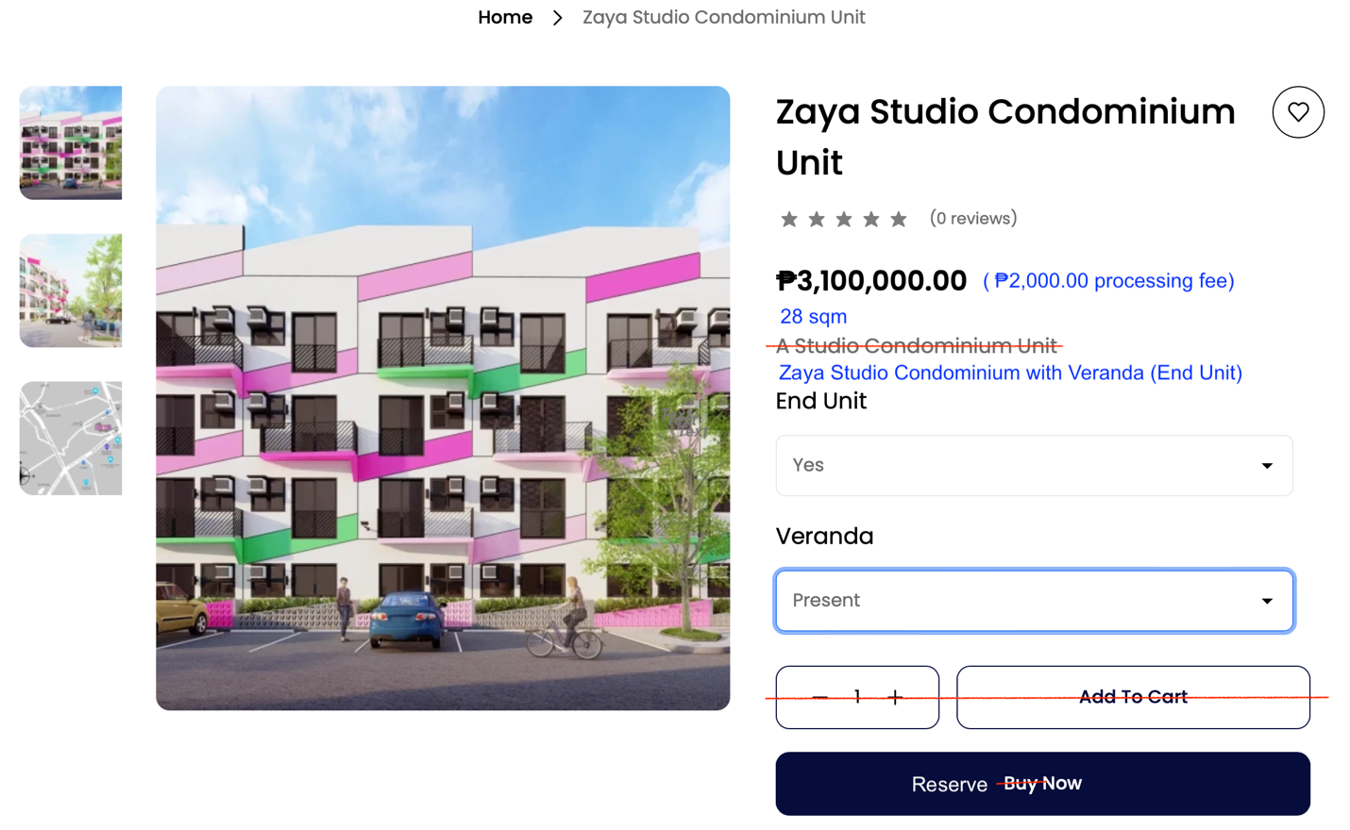

1. AUTO UPDATE the variant “Short Description”, “Description” lookup attributes in the Product Display page upon configuration
2. REPLACE “Billing Address” with “Choose Property…” in the checkout page
3. DEVELOP PROPERTY SELECTOR module for the customer to choose the exact property to reserve
   1. just like the reservation process in airlines industry
      1. choose the flight first (in this case choose the product)
      2. choose between economy, business and 1st class (in this case choose the variation of the product)
      3. and then choose the exact seats (in this case choose the actual property) –sometimes mandatory, sometimes optional depending on the flight (in this case mandatory)
   2. all available properties should be aggregated by count and submitted to the system as inventory
   3. each parcel is represented by a “Property Code” that points to a specific property in the sales inventory – this should be recorded as part of the reservation process.
   4. the “Property Code” is like the “Serial Number” of a product
4. RETRIEVE “Property Code” from the property map and populate the form field. If not yet interactive, just make it editable, the value can be manually entered by buyer using a printed key map of the project
5. INVOKE “Authenticate”, required before confirming
   1. this (HTTP GET external API call) will trigger eKYC process
      1. authenticate buyer
      2. capture ID card details specifically “Full Name”, “Full Address”, “Birthdate”, “ID Type” and “ID Number”
      3. transmit the ID card details together with the above-mentioned “Property Code” to a separate, external RESERVATION SYSTEM
   2. retrieve the ID card details and populate the “Billing Address” form fields
   3. enable the “Confirm” button

Envisioned Checkout Page

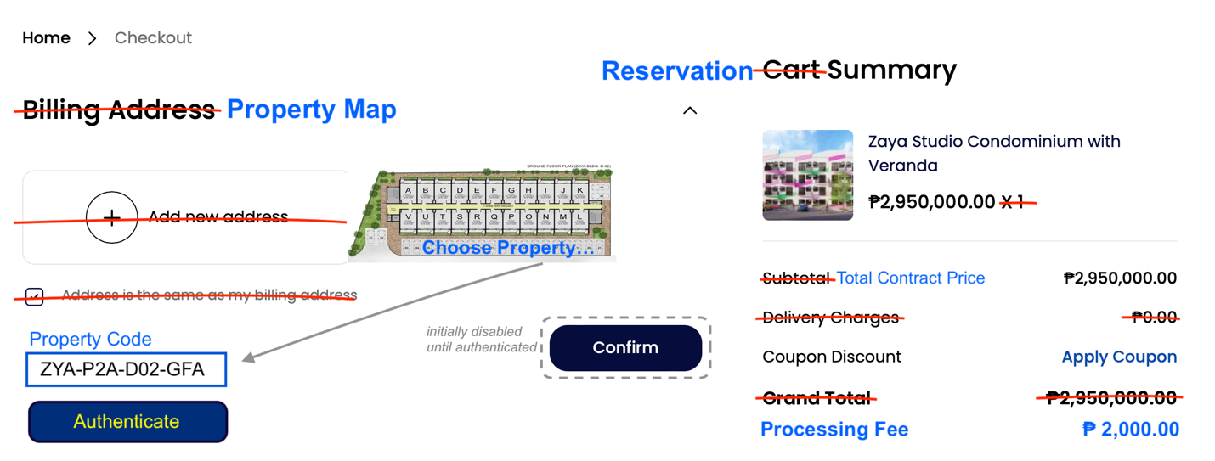

1. RENAME invoice number to RESERVATION CODE
   1. invoice is for the processing fee and not for the price of the property
   2. the RESERVATION CODE becomes the reference in paying for the processing fee
2. INTEGRATE a payment gateway compatible with Philippine banking system
3. CONNECT the customized Bagisto eCommerce platform to the customized Krayin CRM